2784. Check if Array is Good

Question :[ https://leetcode.com/problems/check-if-array-is-good/submissions/2002709237/?envType=daily-question&envId=2026-05-14 ]

Solution :

Explanation
For a good array:
- Maximum number = n
- Array must contain:
  - 1, 2, 3, ..., n-1 exactly once
  - n exactly twice
So:
- Find n = max(nums)
- Length must be n + 1
- Sort the array
- Check:
  - First n-1 elements are 1 to n-1
  - Last two elements are n

Example
Input:
nums = [1,3,3,2]
After sorting:
[1,2,3,3]
- 1,2 appear once
- 3 appears twice
Answer:
True

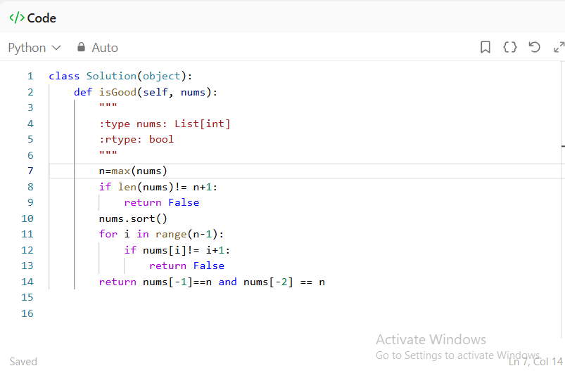

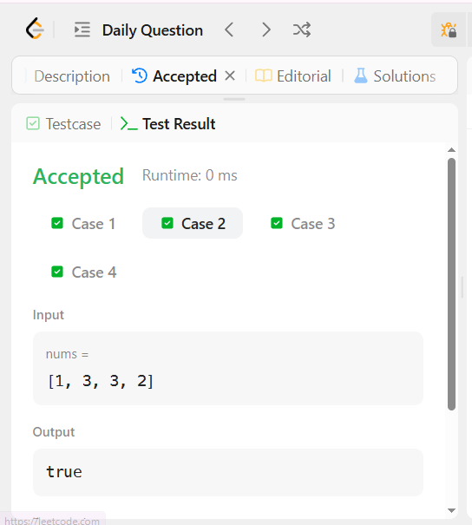

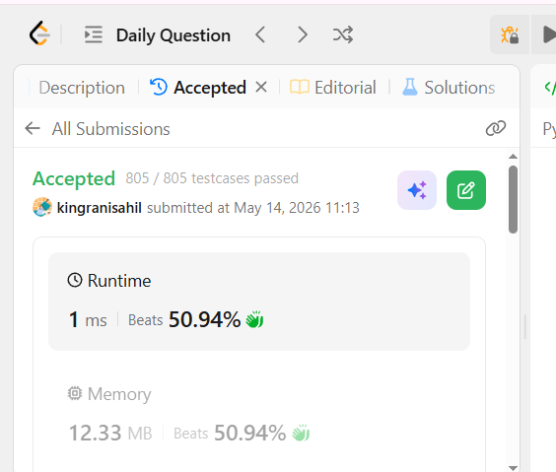

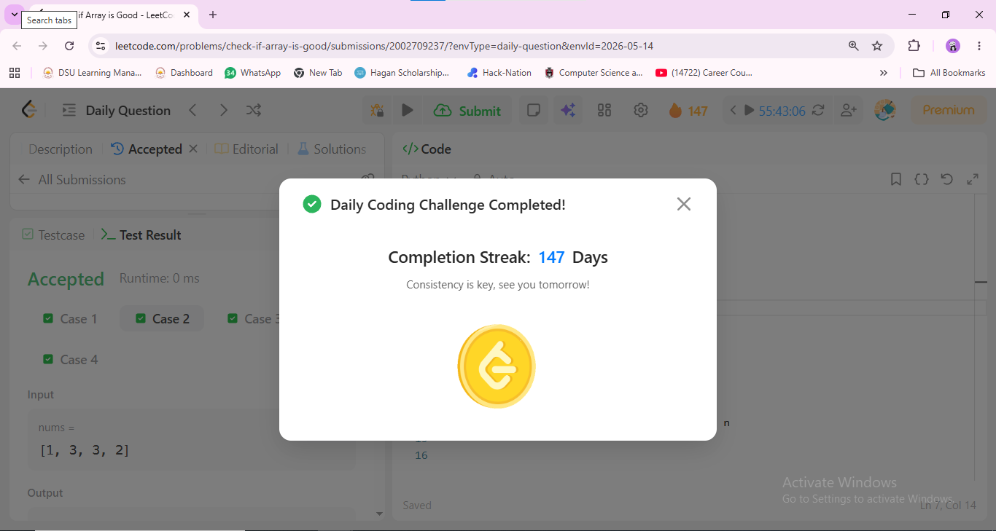

Time & Space Complexity
Time : O(n log n)
Space : O(1)

